Capstone Project & Incident Response
Jemimaal.R
B.Sc. IT

INDEX

SR.NO | TITLE | PAGE NO.
1 | Project Planning | 2
2 | Capstone Project Selection | 4
3 | Implementation | 12
4 | Incident Response Simulation | 16
5 | Final Documentation | 20
6 | Presentation | 20

CAPSTONE PROJECT & INCIDENT RESPONSE
TASK – 5
PROJECT PLANNING
1. Objectives
The objective of this project is to perform a security assessment of the Damn Vulnerable Web Application (DVWA) in a controlled laboratory environment. The project aims to identify common web application vulnerabilities such as SQL Injection, Cross-Site Scripting (XSS), and weak authentication mechanisms. The assessment will help understand how attackers exploit vulnerabilities and how appropriate security controls can mitigate these risks.
Expected Outcome:
- Identify vulnerabilities present in DVWA.
- Demonstrate controlled exploitation techniques.
- Analyze security weaknesses.
- Recommend suitable mitigation measures and best practices.
2. Scope
Target System:
- DVWA (Damn Vulnerable Web Application)
Target IP Address:
- 192.168.108.128
Applications Included:
- DVWA Web Application
Allowed Activities:
- Port Scanning
- Vulnerability Scanning
- SQL Injection Testing
- Cross-Site Scripting (XSS) Testing
- Brute Force Testing (Controlled Environment)
Restrictions:
- No Denial of Service (DoS) attacks.
- No attacks outside the laboratory environment.
- No unauthorized access to external systems.
3. Tools Used
Tool | Purpose
Kali Linux | Penetration Testing Platform
Nmap | Port and Service Scanning
Nikto | Web Vulnerability Scanning
SQLMap | SQL Injection Testing
Hydra | Brute Force Testing
DVWA | Vulnerable Target Application

4. Timeline
Day | Task
Day 1 | Environment Setup and Configuration
Day 2 | Reconnaissance and Port Scanning
Day 3 | Vulnerability Assessment using Nikto
Day 4 | SQL Injection, XSS, and Brute Force Testing
Day 5 | Incident Response Simulation and Documentation
Day 6 | Final Report Preparation and Submission

CAPSTONE PROJECT SELECTION
Project Topic - Web Application Pentest Report on DVWA
1: Setup Environment
Start both VMs:
- Kali Linux
- DVWA Machine
Verify connectivity:
ping <DVWA-IP>

Kali Linux
(Attacker)

DVWA Server(Target)

Network Diagram of the Testing Environment

Router / Network

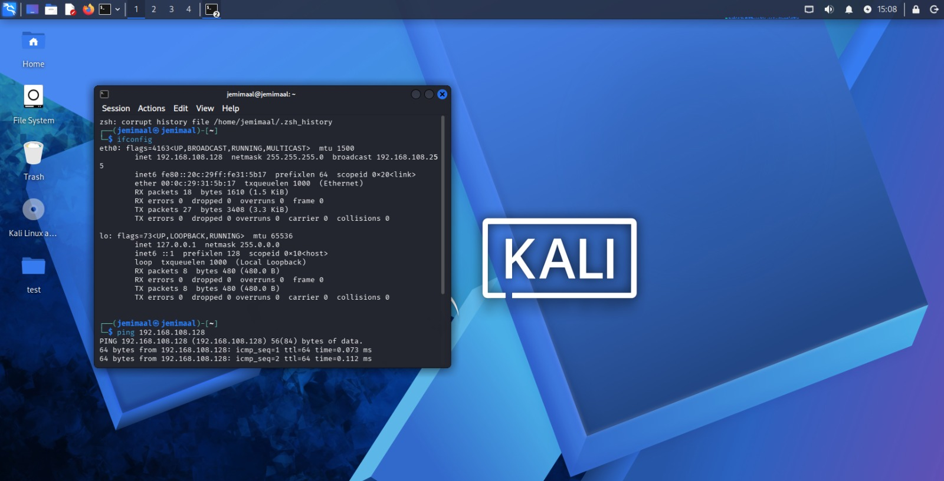
Fig 1: ping
2: Reconnaissance
Find open ports and services:
nmap -sV <DVWA-IP>
Identify:
- Open Ports
- Running Services
- Version Information
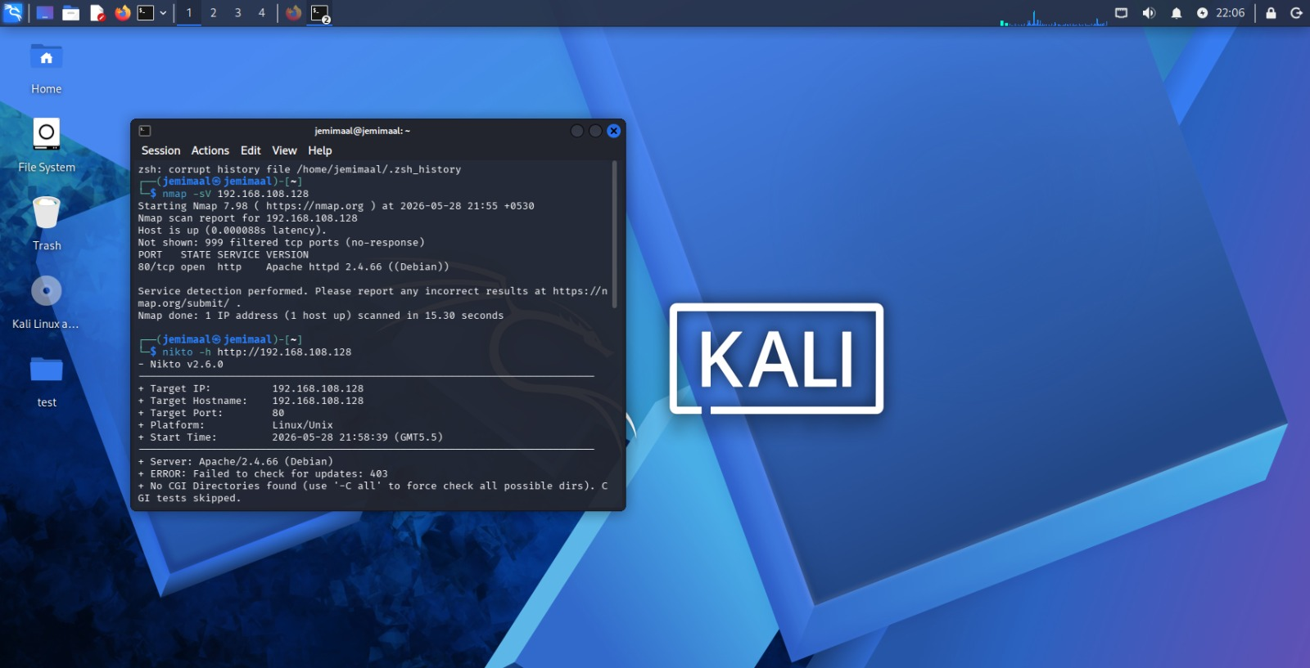 Fig 2: nmap
3: Vulnerability Scanning
Run Nikto:
nikto -h http://<DVWA-IP>
Observe:
- Vulnerable files
- Security misconfigurations
- Missing headers
 Fig 3: nikto

4: SQL Injection Testing
Open DVWA:
DVWA
- Enter Username
- Enter Password
SQL Injection
- Enter ID
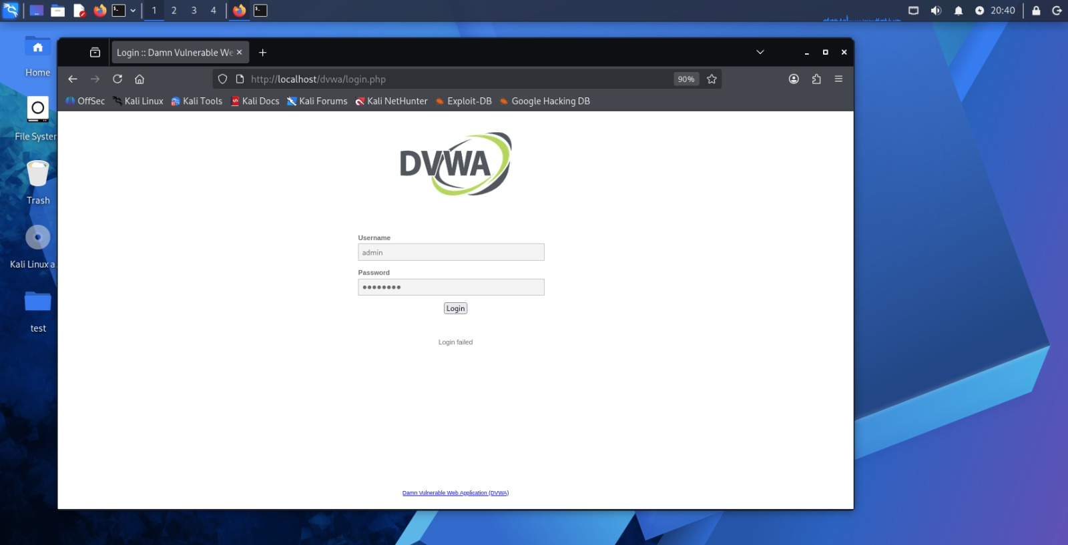
Fig 4: dvwa login page

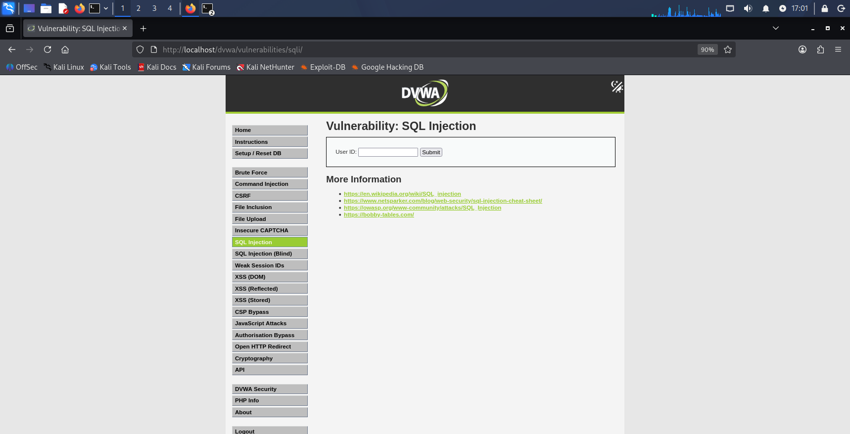
Fig 5: sql injection(i)

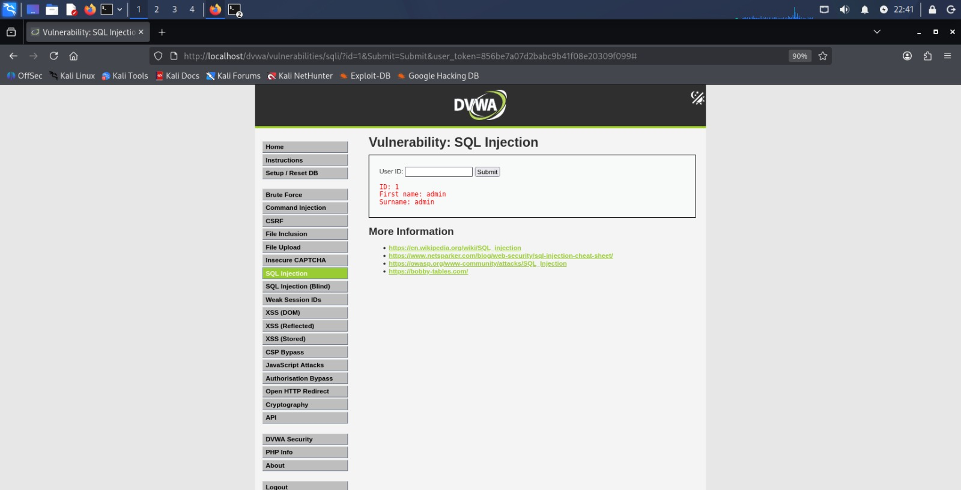
Fig 6: sql injection(ii)

5: SQLMap Testing
Example:
sqlmap -u "http://<DVWA-IP>/dvwa/vulnerabilities/sqli/?id=1&Submit=Submit#" --dbs
If authentication is required, include cookies.

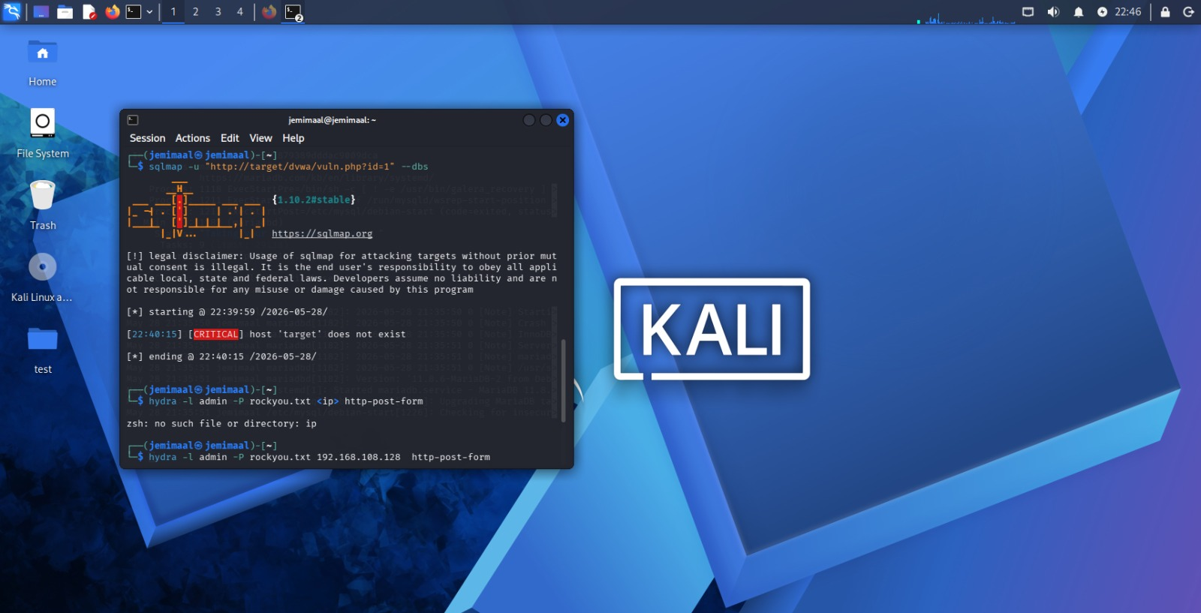
Fig 7: sqlmap

6: Cross-Site Scripting (XSS)
Go to:
DVWA XSS (Stored)
Inject:
<script>alert('XSS')</script>
Alert box should appear.
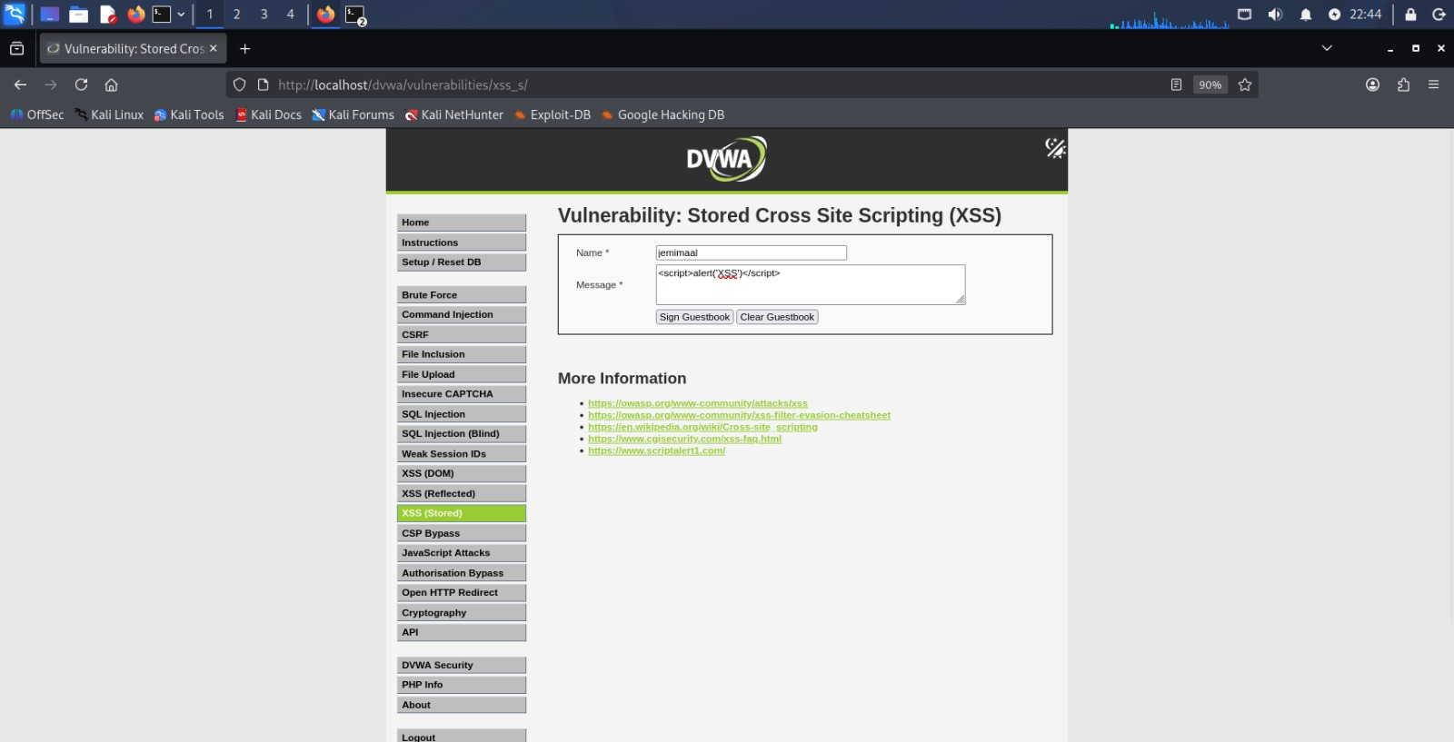
Fig 8: xss(i)

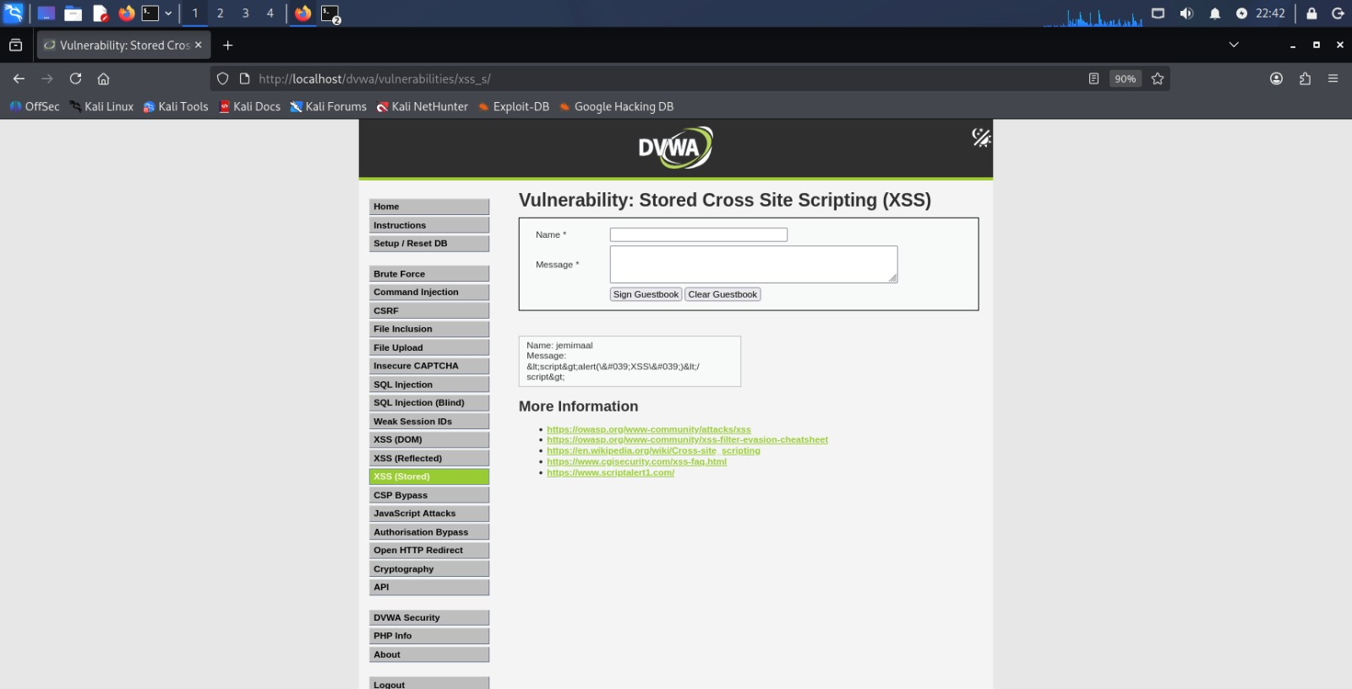 Fig 9: xss(ii)
7: Command Injection
Go to:
DVWA Command Injection
Enter:
192.168.108.128
Click Submit.
The application executes the ping command and displays the network response.

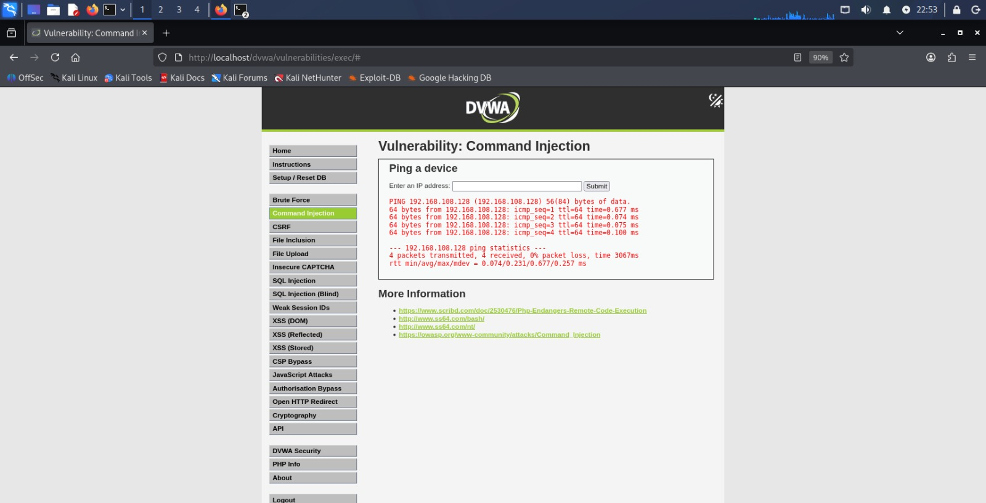
Fig 10: command injection

8: Brute Force Attack
Go to:
DVWA Brute Force
Use Hydra:
- hydra -l admin -p password 127.0.0.1 http-get-form "/dvwa/vulnerabilities/brute/:username=^USER^&password=^PASS^&Login=Login:F=Username and/or password incorrect"
- hydra -l admin -p password 127.0.0.1 http-get-form "/dvwa/vulnerabilities/brute/:username=^USER^&password=^PASS^&Login=Login:Username and/or password incorrect"
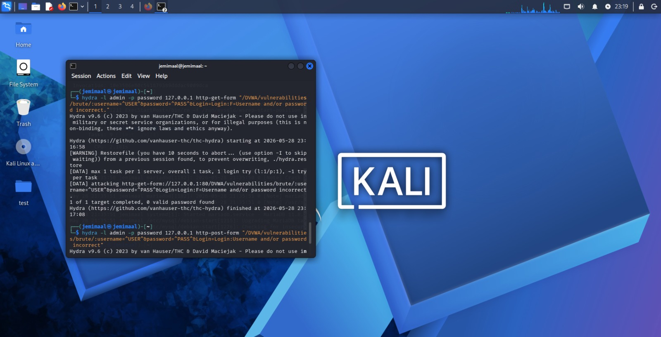
Fig 11: hydra(i) execution

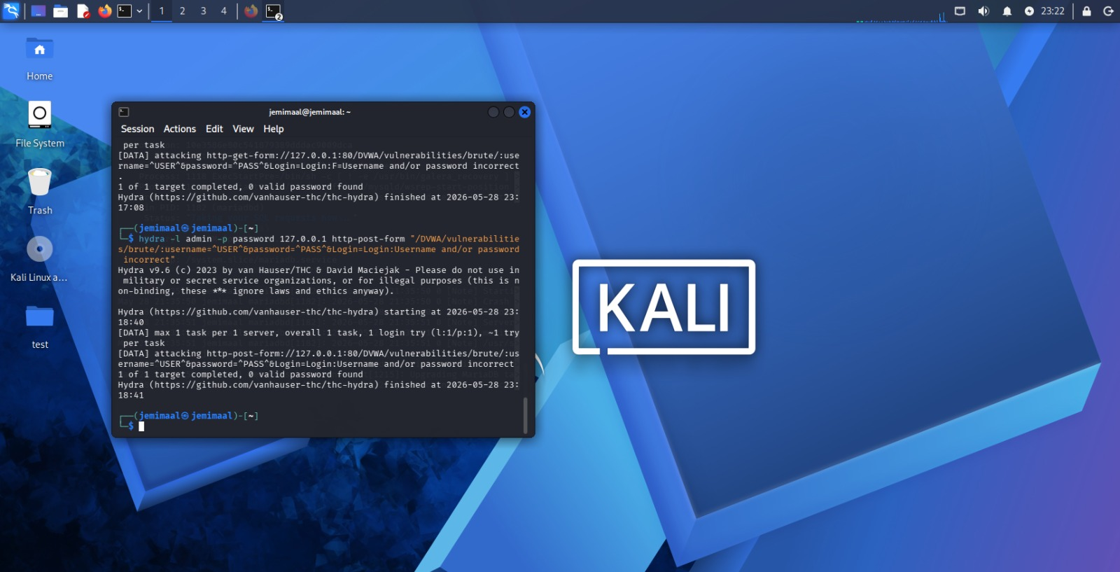
Fig 12: hydra(ii) execution
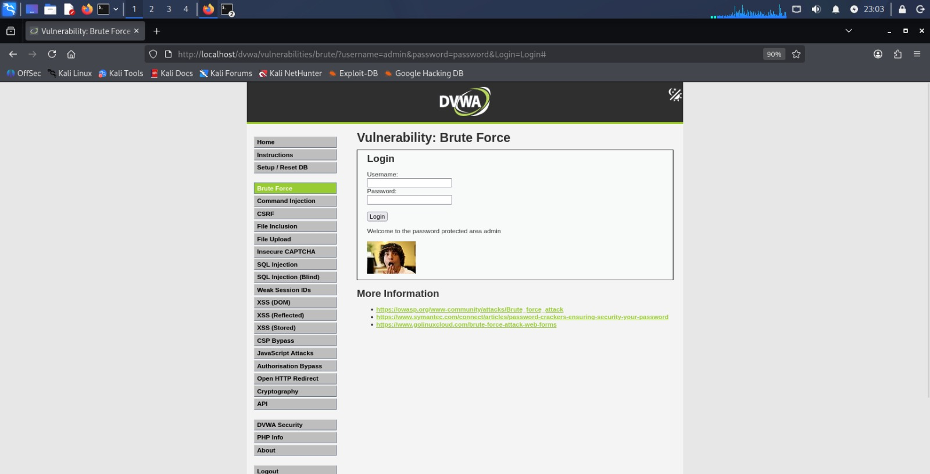
Fig 13: Successful Login (DVWA)

IMPLEMENTATION
1. Conduct Reconnaissance
Reconnaissance was performed to gather information about the target DVWA application. The IP address, web technologies, and server information were identified using reconnaissance tools such as WhatWeb and Nmap.
Information collected:
- IP address
- Localhost details
- Web application information

Commands Used
- ip a
- whatweb http://localhost/dvwa
If whatweb not installed:
- sudo apt install whatweb

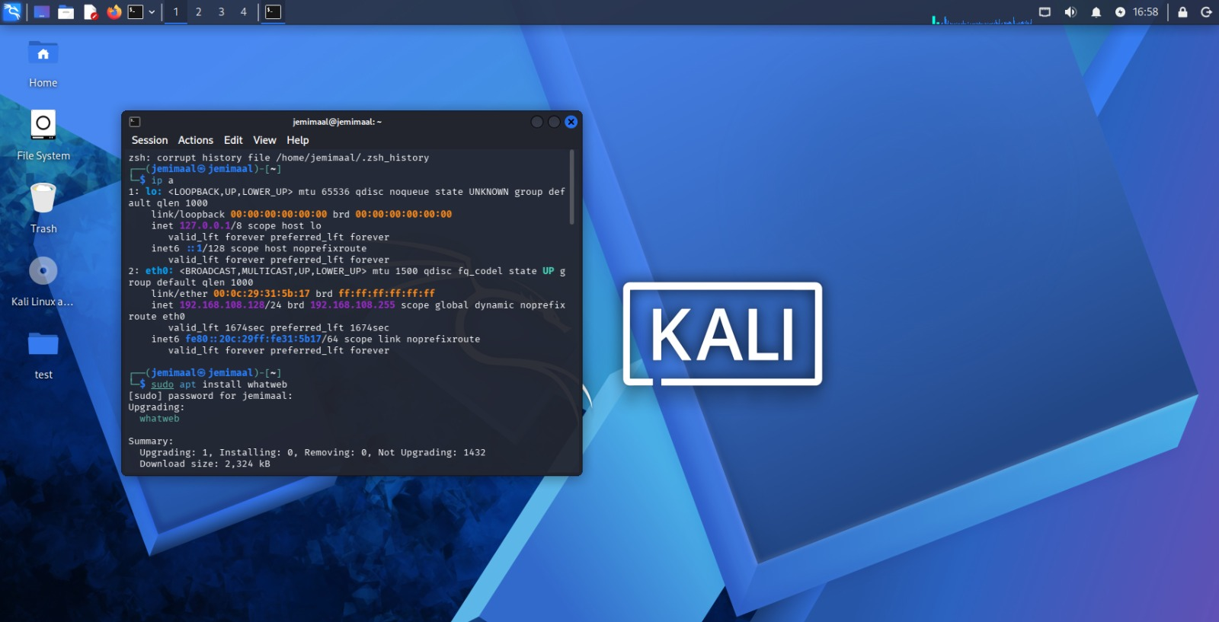
Fig 14: ip a, whatweb

2. Scanning
Scanning was performed using Nmap and Nikto to identify open ports, running services, and possible web vulnerabilities. The scans revealed active HTTP services and common web server configurations.
Port Scan
Command:
nmap -sS -A 127.0.0.1
Service Detection
nmap -sV 127.0.0.1
Vulnerability Scan
nikto -h http://localhost
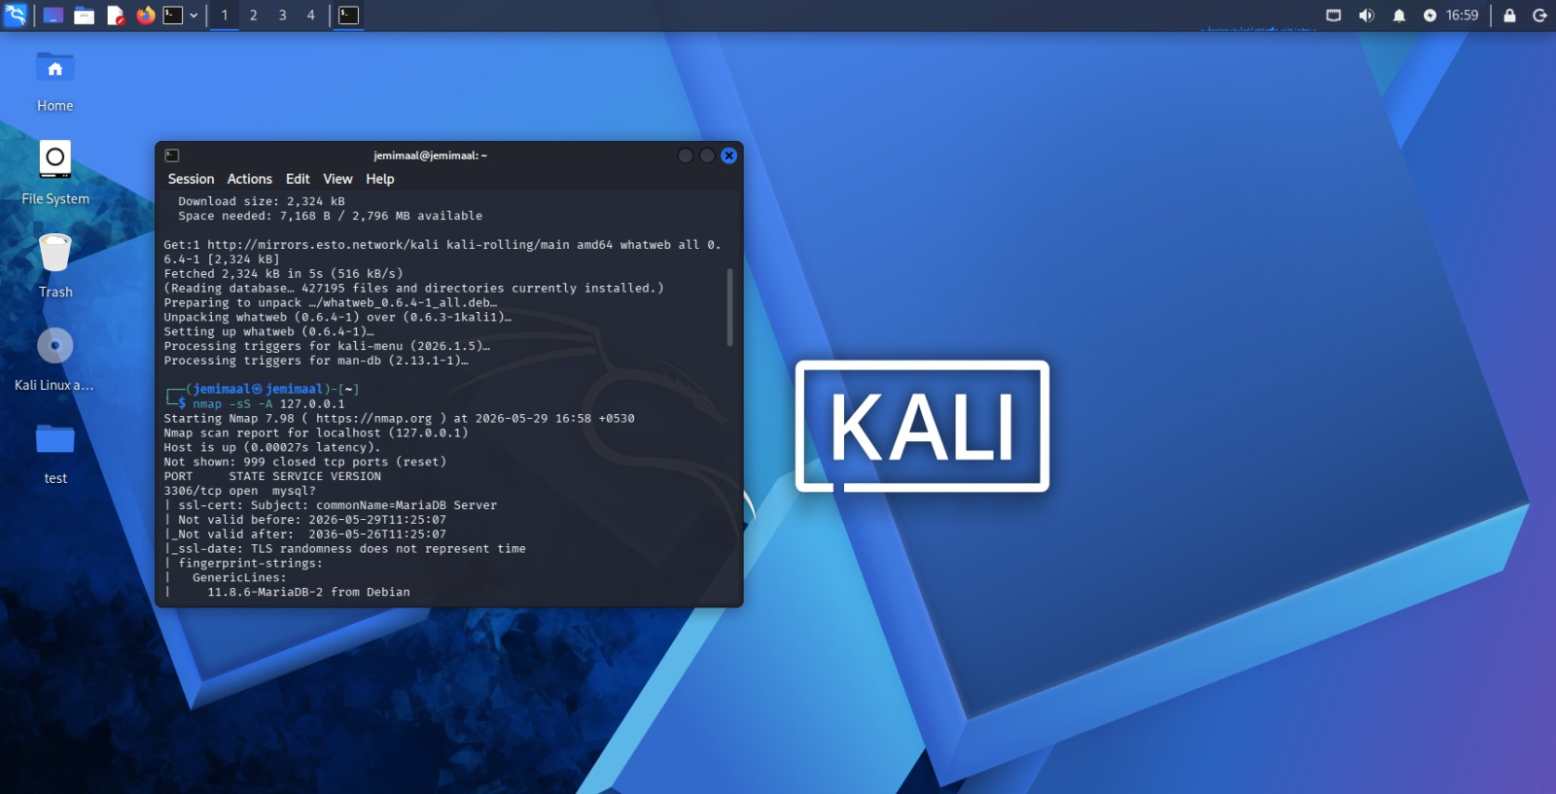
Fig 15: nmap -sS -A 127.0.0.1

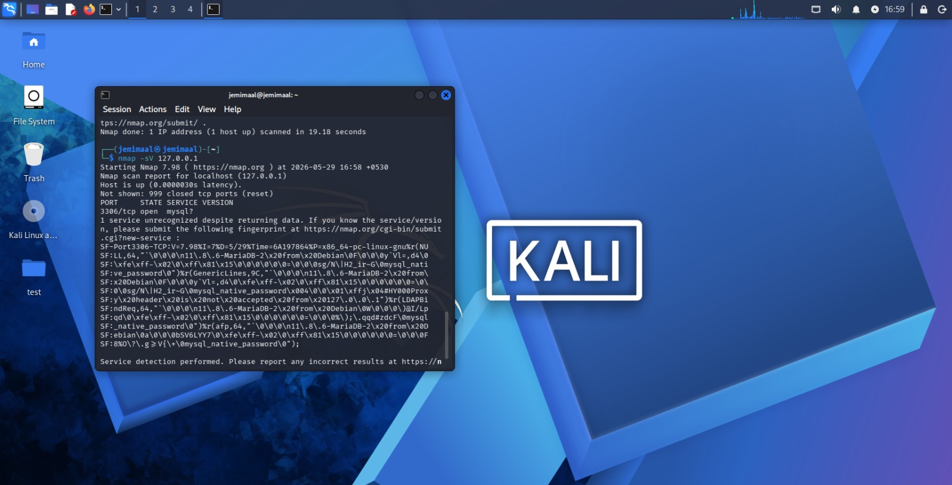
Fig 16: nmap -sV 127.0.0.1

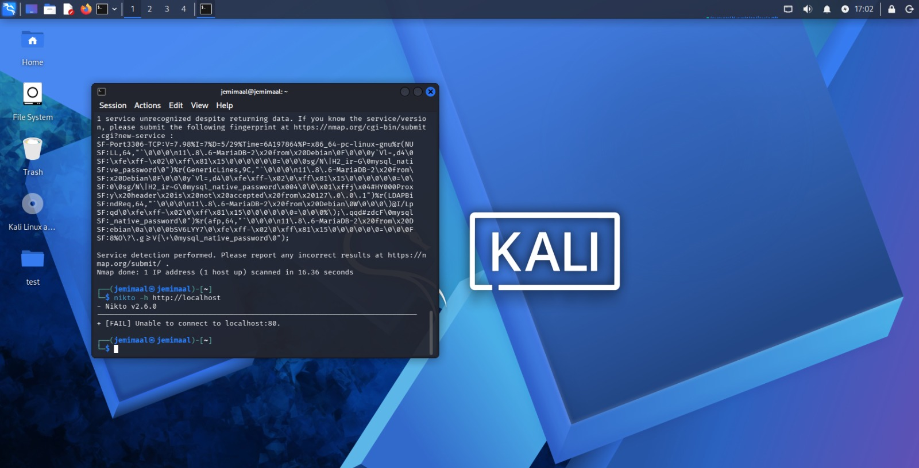
Fig 17: nikto -h http://localhost

3. Exploitation
Controlled exploitation was performed on the DVWA application to verify the presence of identified vulnerabilities. Various attack techniques including SQL Injection, Cross-Site Scripting (XSS), Command Injection, and Brute Force Authentication testing were conducted within a controlled laboratory environment.
The SQL Injection vulnerability was successfully exploited using specially crafted input, demonstrating how improper input validation can lead to unauthorized database access. Cross-Site Scripting (XSS) testing confirmed that malicious scripts could be executed within the application's context. Command Injection testing demonstrated the application's ability to process user-supplied input without sufficient validation. Brute Force testing highlighted weaknesses in authentication mechanisms and the risks associated with weak credentials.
The exploitation activities helped assess the potential impact of these vulnerabilities and provided valuable insight into how attackers may compromise web applications if appropriate security controls are not implemented.

INCIDENT RESPONSE SIMULATION
1. Detect Attack in Logs
Attack activity was monitored using Apache access logs. Multiple suspicious requests and repeated login attempts were identified during penetration testing. The logs helped detect abnormal traffic generated by brute force and web exploitation attempts.
Open terminal and type:
- cat /var/log/apache2/access.log
This shows:
- login attempts
- DVWA requests
- Hydra requests
- SQL Injection requests
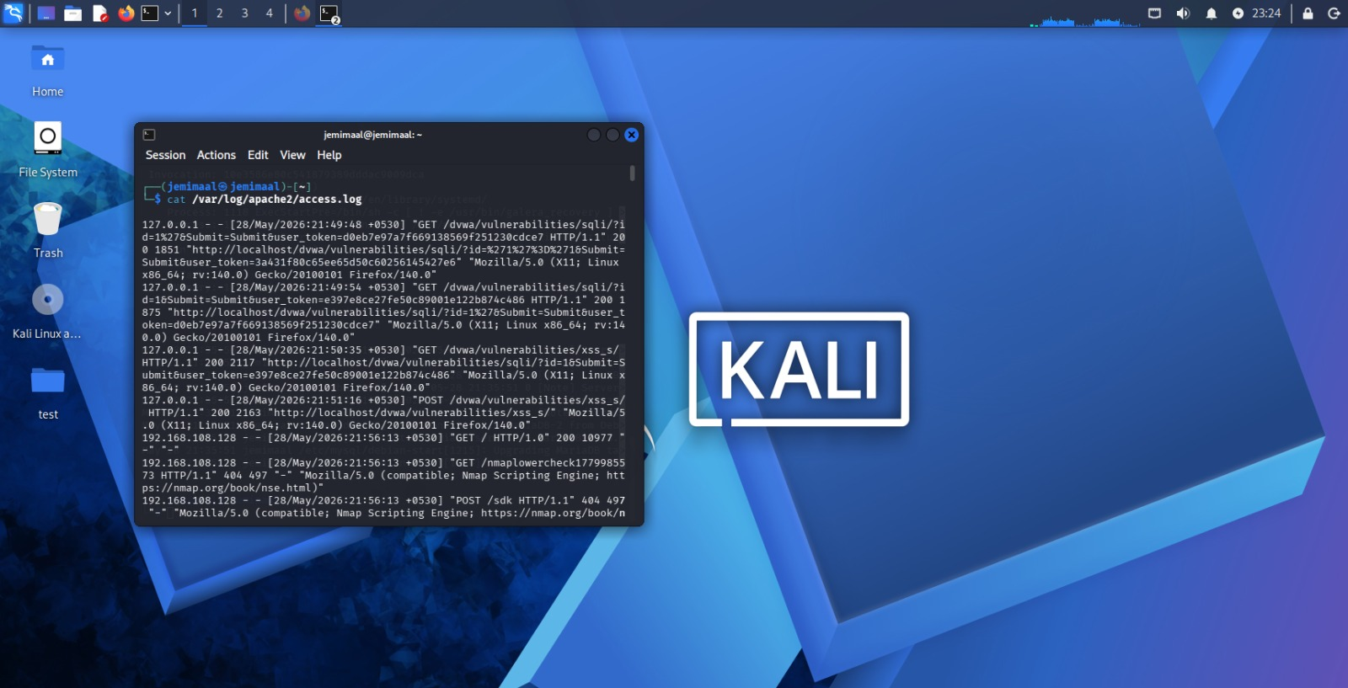
Fig 18: logs(i)

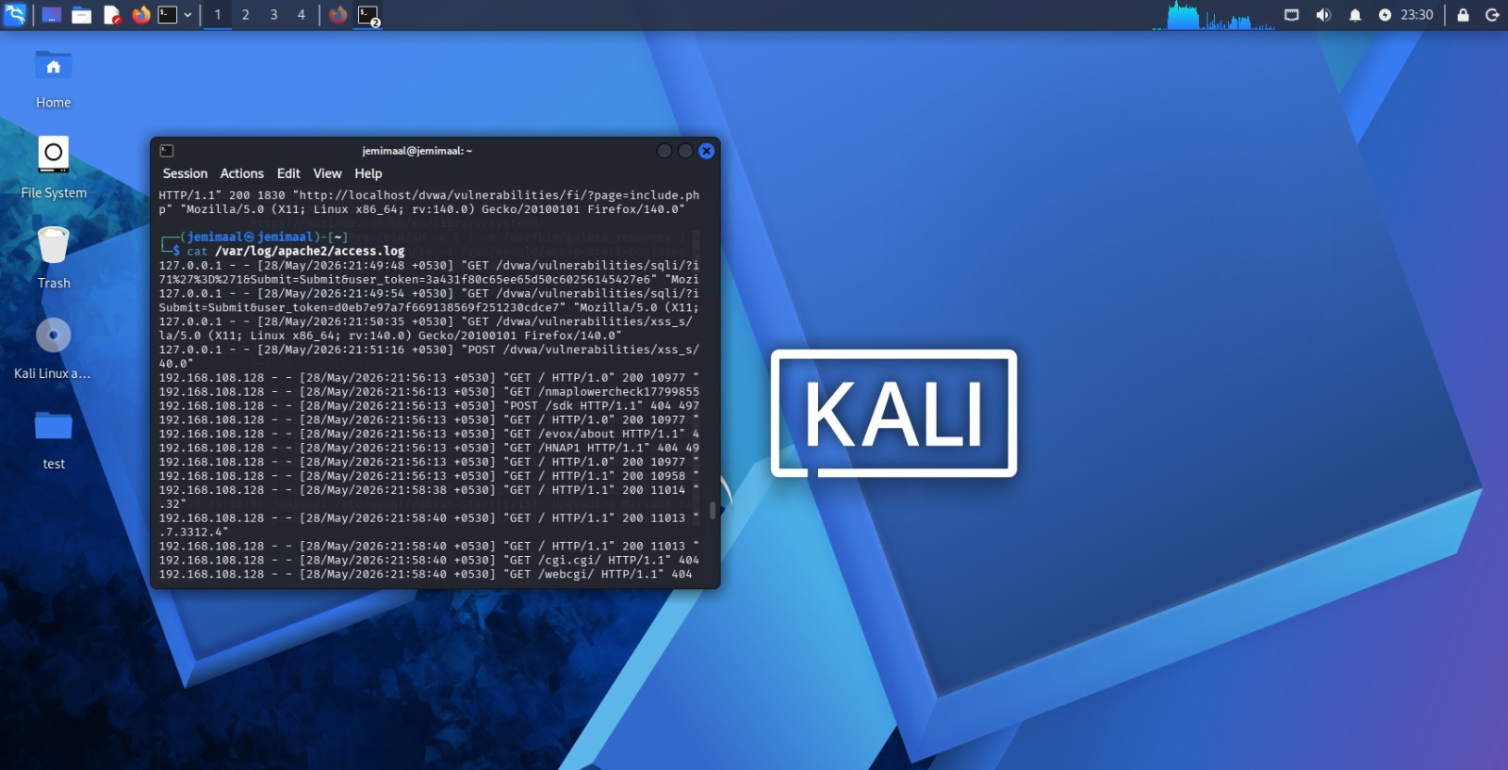
Fig 19: logs(ii)
2. Contain the Threat
To contain the simulated attack, firewall rules were applied using UFW to block suspicious IP activity. This prevented further unauthorized requests from the attacking source.
Enable firewall:
- sudo ufw enable
Block IP: sudo ufw deny from 127.0.0.1
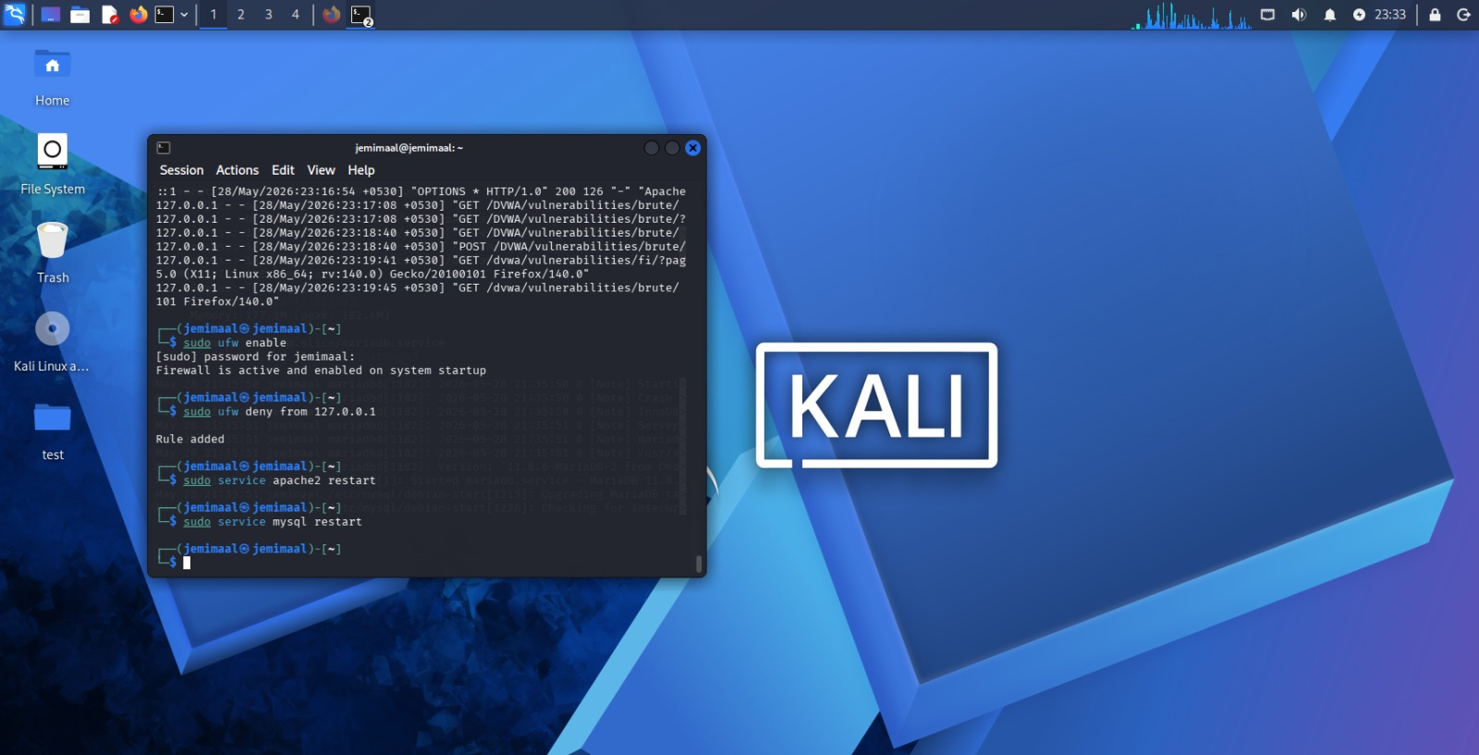
Fig 20: sudo
3. Eradicate Threat
The identified vulnerabilities were analyzed and mitigation strategies were recommended. Web services were restarted after testing to restore normal system operation and remove temporary attack conditions.
Restart services:
- sudo service apache2 restart
- sudo service mysql restart

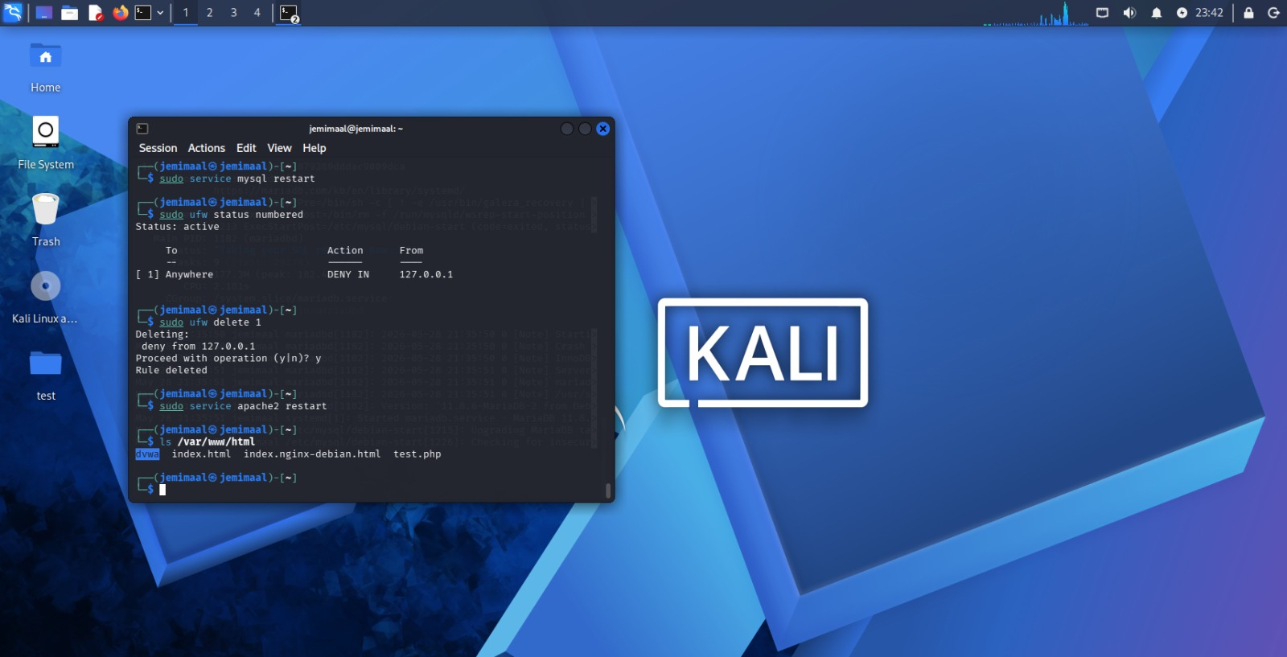
Fig 21: services

4. Recovery
Recovery procedures included restoring normal access to the DVWA application, verifying Apache and MySQL services, and ensuring the web application functioned correctly after testing activities.
Open browser:
- http://localhost/dvwa
Verify DVWA works again.
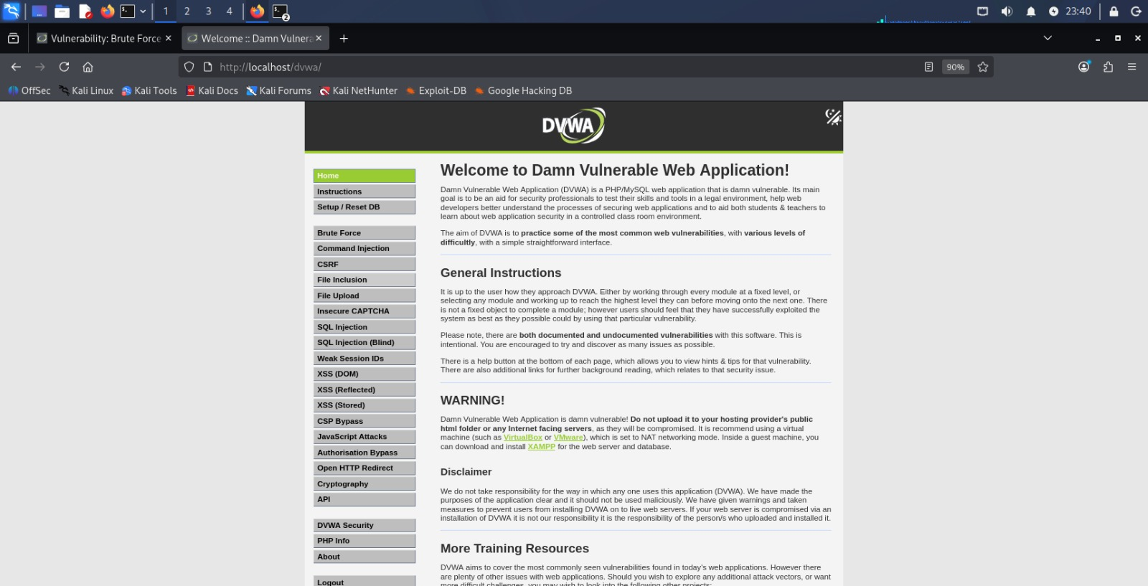
Fig 22: Verified DVWA

Mitigation Recommendations
Vulnerability | Recommendation
SQL Injection | Use prepared statements and parameterized queries. Validate and sanitize user inputs before processing.
Cross-Site Scripting (XSS) | Implement input validation and output encoding. Filter malicious scripts from user input.
Brute Force Attacks | Enable account lockout policies, rate limiting, CAPTCHA, and Multi-Factor Authentication (MFA).
Information Disclosure | Disable unnecessary services and remove sensitive information from error messages.
Weak Authentication | Use strong password policies and enforce regular password updates.
Server Misconfiguration | Regularly update software, apply security patches, and follow secure configuration guidelines.

General Security Recommendations
- Conduct regular vulnerability assessments and penetration testing.
- Keep operating systems and applications updated.
- Implement a Web Application Firewall (WAF).
- Monitor logs for suspicious activities.
- Follow secure coding practices during application development.

FINAL DOCUMENTATION
A comprehensive penetration testing report was prepared to document all activities performed during the security assessment of DVWA. The report includes project objectives, scope, tools used, reconnaissance results, vulnerability scanning, exploitation findings, incident response activities, mitigation recommendations, and supporting screenshots.
Documentation Included:
• Project Planning
• Reconnaissance and Scanning Results
• SQL Injection Testing
• Cross-Site Scripting (XSS) Testing
• Command Injection Testing
• Brute Force Authentication Testing
• Incident Response Simulation
• Mitigation Recommendations
The final report was organized in a professional format and prepared for submission as part of the cybersecurity internship capstone project.

PRESENTATION
A final presentation was prepared to demonstrate the complete workflow of the capstone project. The presentation covered project objectives, testing methodology, tools used, reconnaissance activities, vulnerability assessment, exploitation results, incident response simulation, and mitigation recommendations.
Presentation Contents:
• Project Introduction
• Objectives and Scope
• Tools and Environment Setup
• Reconnaissance and Scanning
• Vulnerability Exploitation
• Incident Response Simulation
• Findings and Recommendations
• Conclusion
The presentation summarized the security assessment process and highlighted the importance of secure coding practices and regular security testing.

CONCLUSION
This project successfully demonstrated the identification and assessment of common web application vulnerabilities in DVWA, including SQL Injection, Cross-Site Scripting (XSS), Command Injection, and Brute Force Authentication. Security testing was performed in a controlled laboratory environment using various penetration testing tools. The findings highlighted the importance of secure coding practices, proper input validation, strong authentication mechanisms, and regular security assessments. Appropriate mitigation measures were recommended to improve the overall security of web applications.

